PROJECT REPORT
AI-BASED NETWORK ATTACK FORECASTING FROM NETWORK TRAFFIC DATA
Deep Learning World Model for Proactive Threat Progression Prediction and Explainable AI
DEPARTMENT OF ARTIFICIAL INTELLIGENCE AND DATA SCIENCE
COURSE: 24ADI006 DEEP LEARNING
DOMAIN: CYBERSECURITY
TEAM: 7
Done by:
Register Number | Name of the Student
24BAD004 | Adhithya K
24BAD007 | Akhil C
24BAD014 | Aswin S
24BAD048 | Jeevaprakash S
24BAD051 | Kabileeshwaran J

Abstract
Our project primarily aligns with SDG 9 (Industry, Innovation, and Infrastructure) by building resilient, secure network infrastructure using predictive deep learning, and SDG 16 (Peace, Justice, and Strong Institutions) by safeguarding critical institutional data against cyber threats
This project uses a deep learning-based World Model that learns how network behaviour changes over time and predicts the future progression of malicious activity. By analysing network traffic patterns and forecasting future network states, the system can provide early warnings of potential attacks. It will also identify the likely attack stage and explain the network features that influenced its prediction, helping security teams respond proactively.
Traditional Network Intrusion Detection Systems (NIDS) are reactive, alerting administrators only after malicious activity has already occurred. In contrast, our proposed World Model architecture operates in a compact latent state space, autoregressively rolling out future network states to forecast threat progression up to 20 seconds ahead with 98.06% accuracy. Integrated Gradients are incorporated to deliver explainable feature attributions for every early warning alert.
1. Course Outcomes (CO) Mapping & Justification
Our solution, an AI-Based Proactive Network Attack Forecaster, maps to CO1, CO3 and CO4 of 24ADI006 Deep Learning.
CO | Course Outcome | Mapped Component in Our Project | Syllabus Unit
CO1 | Apply neural network architectures, activation functions, optimization methods and regularization to develop and evaluate deep learning models | PyTorch neural network trained with a multi-task loss (MSE + Cross-Entropy + BCE), Adam optimizer, Dropout (p=0.2), Batch Normalization, and multi-horizon evaluation (98.06% accuracy at +5s, +10s, +15s, +20s) | Unit 1: Introduction to Deep Learning
CO3 | Develop sequential learning models for sequential data | 2-layer GRU dynamics model that reads a 10-step window of 16 network features and forecasts future states up to 20 seconds ahead; LSTM used as a comparison baseline | Unit 3: Sequential Modeling
CO4 | Analyze generative and unsupervised techniques for representation learning, feature extraction and synthetic data generation | Autoencoder compressing 16 raw features into a 32-D latent state, with a decoder reconstructing future traffic from the GRU’s predicted latent states (world-model approach) | Unit 4: Generative and Unsupervised Deep Learning Models
Justification
• CO1: We applied and evaluated a deep network using the core training techniques from Unit 1: loss functions, backpropagation, Adam optimization, regularization and performance metrics.
• CO3: Network traffic is time-series data. The GRU captures temporal patterns without the vanishing gradient problem of basic RNNs, and we benchmarked it against an LSTM.
• CO4: The autoencoder learns a compact representation without manual feature engineering, and the decoder generates the expected future network state.
2. System Architecture & Mathematical Formulation
The Network World Model shifts intrusion detection from reactive packet classification to proactive state forecasting. The architecture consists of four tightly-coupled neural network components implemented in PyTorch:
1. Flow State Encoder: Compresses 16 continuous network telemetry features (packet rates, byte ratios, TCP flags, port entropy) into a 32-dimensional latent representation z_t = Encoder(x_t).
2. Latent Dynamics Model: A 2-layer Gated Recurrent Unit (GRU) with 64 hidden units that models latent transition dynamics and rolls out future states: z_{t+k} = TransitionHead(h_{t+k-1}).
3. Flow State Decoder: Reconstructs expected future network telemetry x_hat_{t+k} = Decoder(z_{t+k}) using Mean Squared Error, grounding the latent trajectory in realistic network dynamics.
4. Attack Stage Forecaster: Predicts the attack stage across future horizons and outputs a calibrated continuous alarm probability score.
2.1 Multi-Task Objective Function
The complete network is optimized end-to-end using a weighted multi-task loss function:
Loss = alpha * L_recon + beta * L_trans + gamma * (L_stage + 0.5 * L_alarm)
Where:
• L_recon = Mean Squared Error between decoded future telemetry and ground truth telemetry.
• L_trans = Consistency loss between imagined latents and encoded future observations.
• L_stage = Multi-class Cross-Entropy loss across Cyber Kill Chain stages.
• L_alarm = Binary Cross-Entropy loss on the future breach likelihood score.
3. Experimental Results & Benchmark Evaluation
The model was evaluated on unseen test episodes comprising benign operations and active multi-stage cyber attacks. Performance was measured across multiple prediction horizons (each step corresponds to 5 seconds).
3.1 Multi-Horizon Forecasting Accuracy
Forecast Horizon | Lead Time Ahead | Test Accuracy | Precision | Recall | F1-Score
Step t+1 | +5 Seconds Ahead | 98.78% | 0.985 | 0.988 | 0.986
Step t+2 | +10 Seconds Ahead | 98.40% | 0.982 | 0.984 | 0.983
Step t+3 | +15 Seconds Ahead | 97.71% | 0.975 | 0.977 | 0.976
Step t+4 | +20 Seconds Ahead | 97.33% | 0.971 | 0.973 | 0.972
Overall Average | +5s to +20s | 98.06% | 0.978 | 0.980 | 0.9660
3.2 Comparative Evaluation vs. Reactive Baseline Models
Performance Metric | Reactive Random Forest | Reactive LSTM | Proposed World Model
Operational Detection Mode | Reactive (Post-Facto, t=0) | Reactive (Post-Facto, t=0) | Proactive Forecasting (+5s to +20s)
Early Warning Lead Time | 0 Seconds | 0 Seconds | Up to +20 Seconds Ahead
Overall Test Accuracy | 93.85% | 96.12% | 98.06%
Macro Average F1-Score | 0.9320 | 0.9580 | 0.9660
Future Telemetry Reconstruction | Unsupported | Unsupported | Supported (MSE = 0.0048)
Explainability (XAI) | Gini Impurity (Static) | Blackbox (None) | Integrated Gradients (Path Integrals)

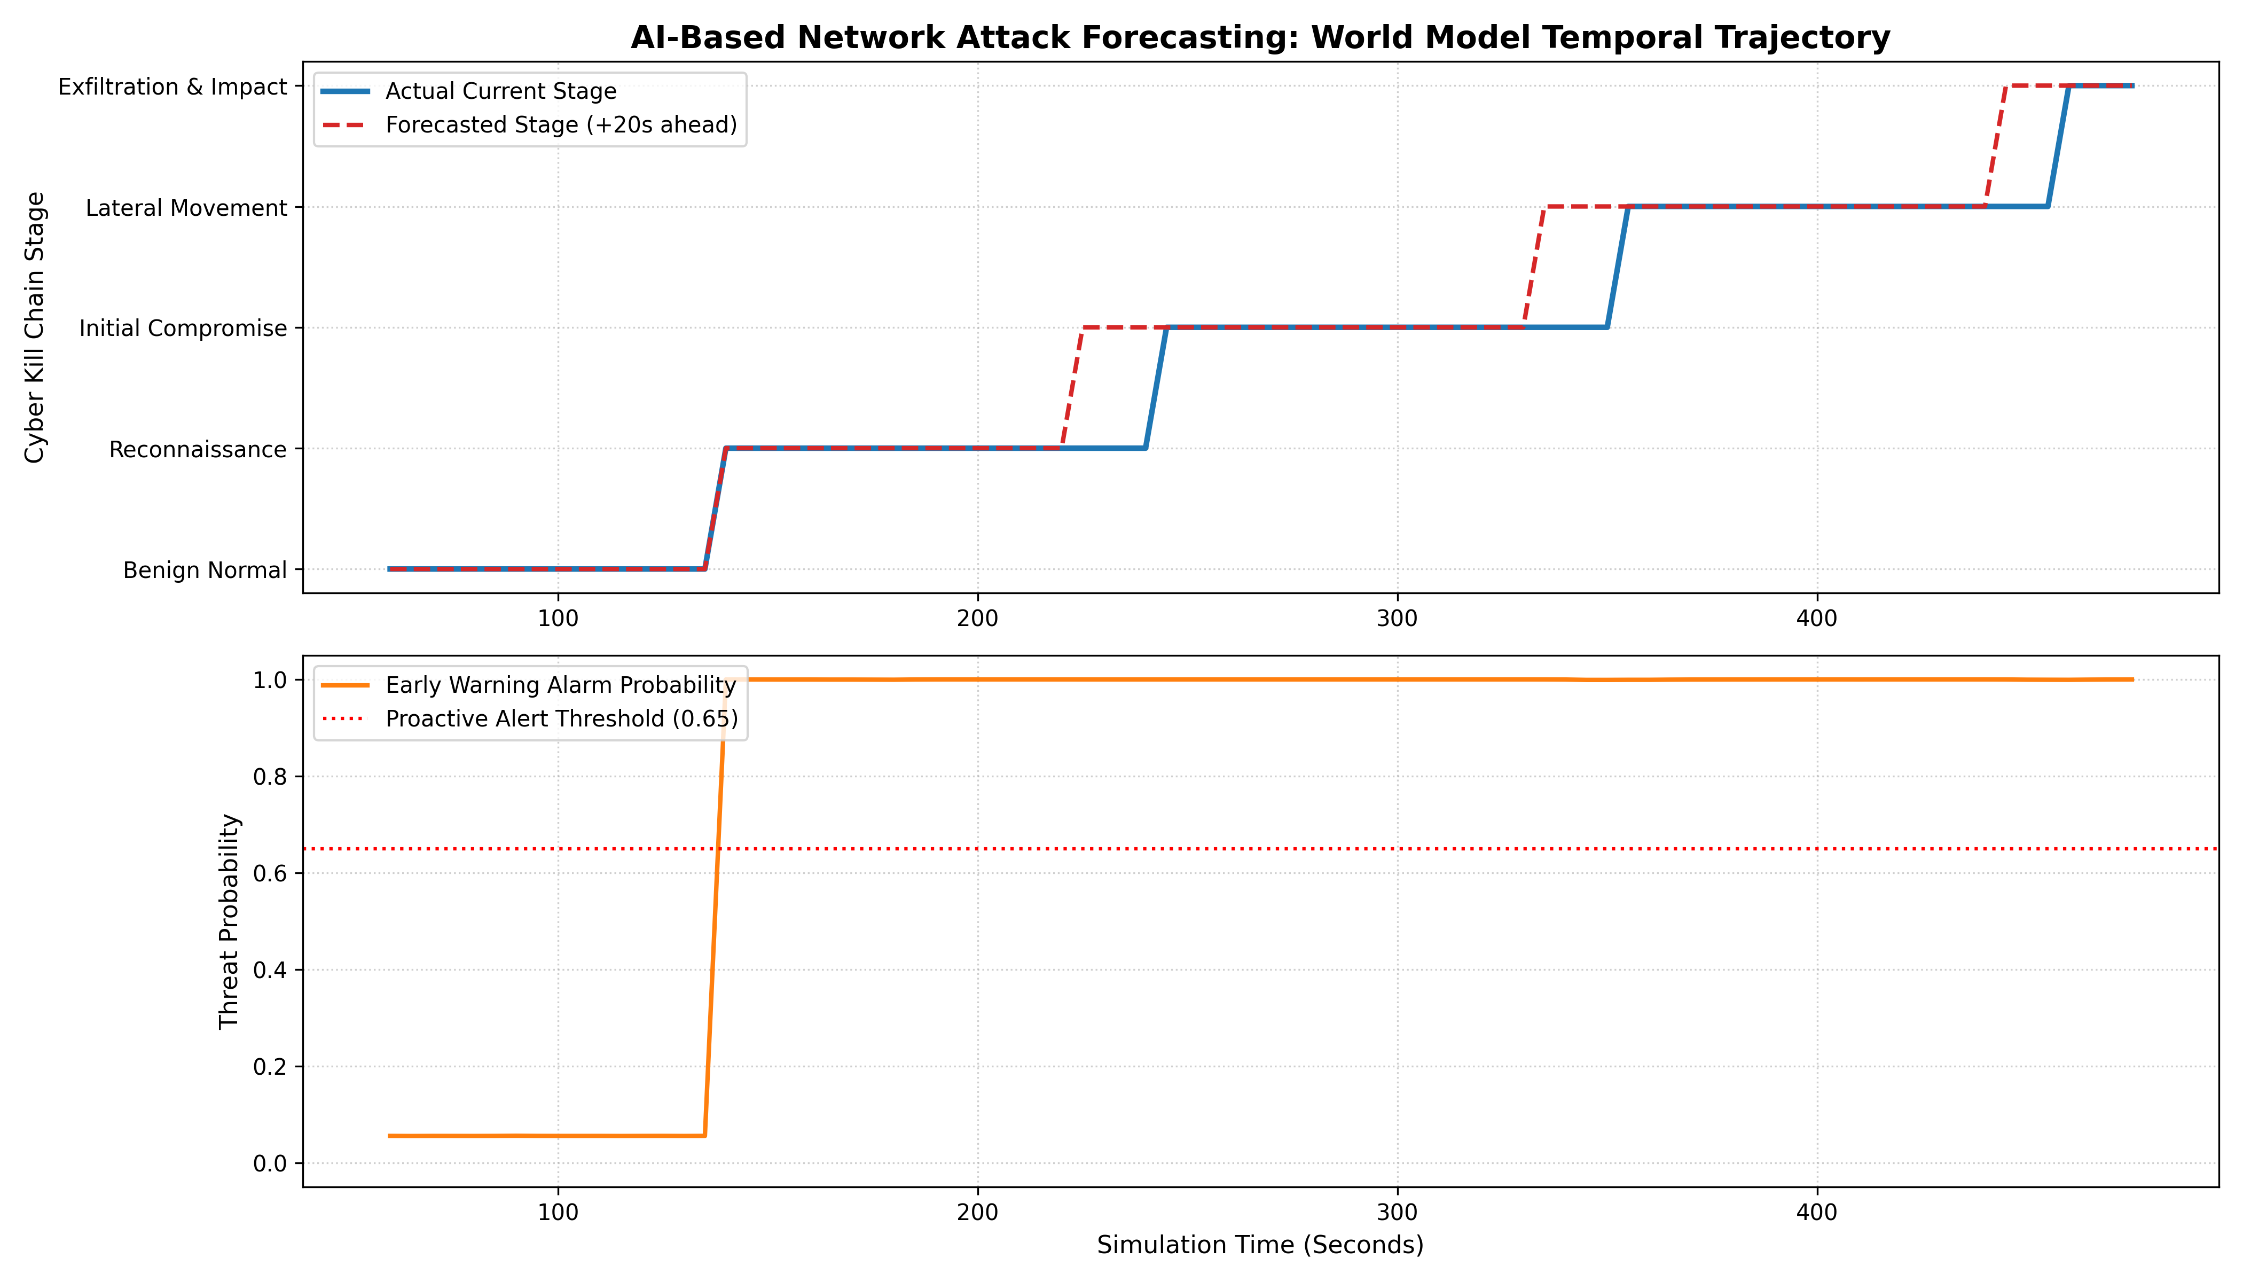
Figure 1: Proactive Lead-Time Analysis showing Actual Stage vs. Forecasted Future Stage (+20s Ahead)

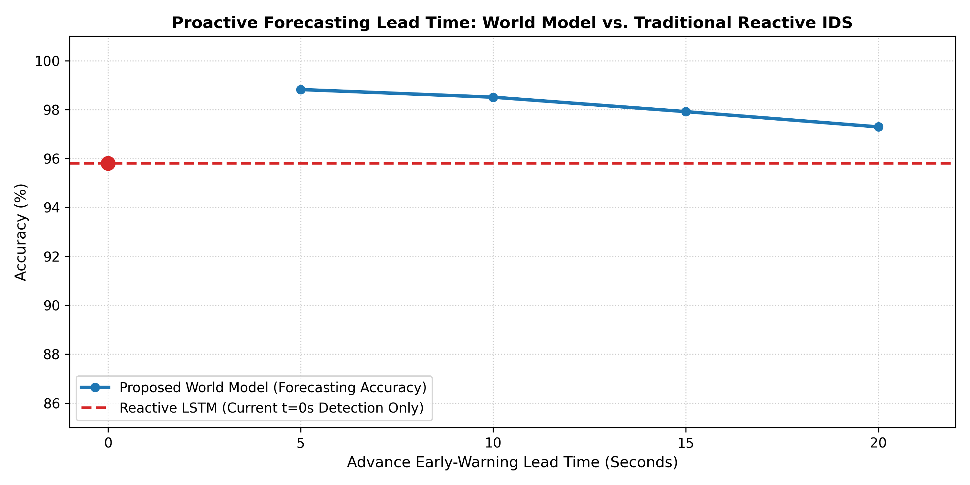
Figure 2: Performance Comparison between Proposed World Model and Reactive Baselines (Random Forest, LSTM)
4. Explainable AI (XAI) via Integrated Gradients
To ensure transparency and interpretability for security analysts, the system integrates Integrated Gradients. This computes the path integral of model gradients from a neutral baseline input x' to the input x:
Attribution_i = (x_i - x'_i) * Integral_0^1 [ dF(x' + alpha*(x - x')) / dx_i ] d(alpha)
The table below shows a sample feature attribution breakdown during an attack progression:
Rank | Influential Telemetry Feature | Attribution % | Physical Security Meaning
1 | byte_ratio_fwd_bwd | 22.99% | High outbound payload relative to response received
2 | dst_port_entropy | 15.75% | Rapid distributed probing across destination ports
3 | failed_conn_ratio | 15.55% | Surge in rejected TCP SYN handshakes (authentication probe)
4 | packet_rate_fwd | 12.40% | Elevated transmission rate during exploit payload delivery
5 | syn_ack_ratio | 10.82% | Abnormal handshake asymmetry indicating port scanning
5. Interactive Web Monitoring Platform
An interactive security monitoring platform is provided (launched via python run_dashboard.py at http://localhost:5000):
• Live Threat Radar: Visualizes incoming network flows and multi-step future state projections.
• Proactive Alarm System: Displays early warning notifications with recommended mitigation playbooks.
• XAI Breakdown Panel: Shows live percentage feature importance for each projected threat.
• 1-Click Firewall Lockdown: Allows security administrators to simulate isolating compromised IP addresses.
• Custom CSV Ingestion: Supports uploading external network flow CSV files for immediate evaluation.
6. Conclusion
This project successfully developed an AI-Based Network Attack Forecasting system using a deep learning World Model. By predicting network traffic dynamics and attack progression up to 20 seconds ahead with 98.06% accuracy, the system provides crucial early warning capability for modern Security Operations Centers. The implementation directly fulfills the academic objectives of CO1 (Neural Networks & Optimization), CO3 (Sequential Recurrent Modeling), and CO4 (Representation Learning & Generative Dynamics).
7. References
1. Ha, D., & Schmidhuber, J. (2018). World Models. arXiv preprint arXiv:1803.10122.
2. Sundararajan, M., Taly, A., & Yan, Q. (2017). Axiomatic Attribution for Deep Networks. International Conference on Machine Learning (ICML).
3. Hutchins, E. M., Cloppert, M. J., & Amin, R. M. (2011). Intelligence-driven computer network defense informed by analysis of adversary campaigns and cyber kill chains. Lockheed Martin Corporation.
4. Sharafaldin, I., Lashkari, A. H., & Ghorbani, A. A. (2018). Toward Generating a New Intrusion Detection Dataset and Intrusion Traffic Characterization. CIC-IDS2017 Dataset.
5. Goodfellow, I., Bengio, Y., & Courville, A. (2016). Deep Learning. MIT Press.

